**Executive Summary**

**Income Analysis of 5000 Individuals**

* **Overview - About the Sample**
  + The following data about 4857 individuals were selected for the analysis
    - Age, Education, Marital Status, Number of Kids, Work hours, and Earnings
  + Some of the data were identified as outliers scrapped off
    - Data rows with number of Kids above 15 were removed
    - Data rows with Education level below 10 and above 30 were removed
* **Some basic Statistics about the Sample**
  + **Averages, Minimums and Maximums**

|  |  |  |  |
| --- | --- | --- | --- |
| **Parameter** | **Average** | **Minimum** | **Maximum** |
| Age | 38 | 30 | 50 |
| Education Level | 13 | 10 | 17 |
| Work Hours | 1320 | 0 | 4200 |
| Earnings | 16,200.00 | 0.00 | 240,000.00 |

* + **Marital Status**

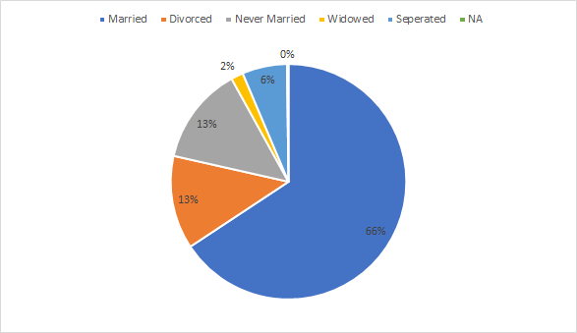

* **Other Findings**
  + **Earnings depend on number of work hours**
    - Work hours impacts the earnings the most in a positive way
      * i.e . More the worked hours more the earlings.
    - Out of the selected individuals, 816 people don’t work at all (and their earnings are also zero)
    - 1447 people work less than 1000 hours and 387 people work for more than 2500 hours

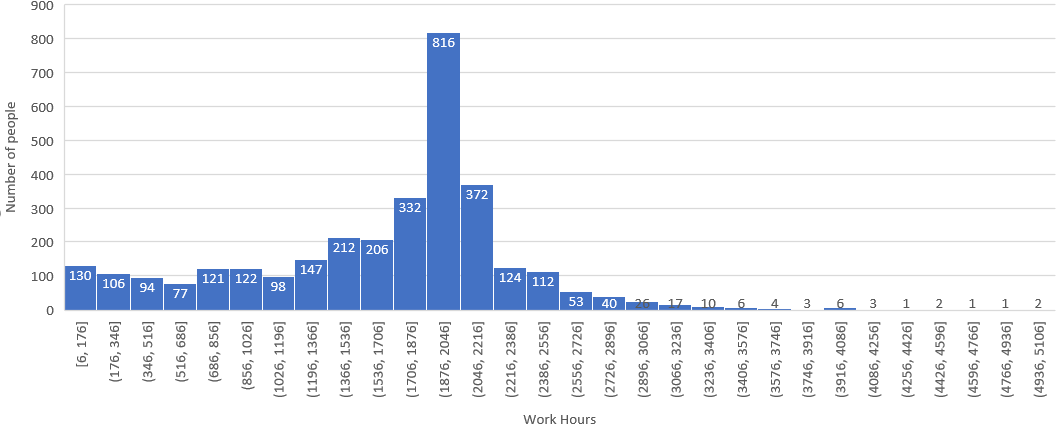

* + **Educated people earn more**
    - Education is the second biggest factor (next to the worked hours) to impact the earnings in a positive way
    - Out of all the selected individuals, 1800 people are with Education level 12

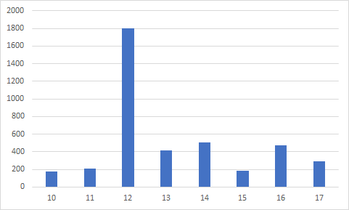

* + **Married people earn more**
    - Married people earn more than the others
    - Average earning of Married people is 16186.00 while the average earning of others is 14664.00
    - Out of the selected individuals, 2668 (66%) people are married